# Two viewpoint image sets

Baoshi Sun (WatID 20625524)

## Experiment Environment

* Computer: Asus M32BF (CPU AMD A10-7800, 12G Memory), Windows 10
* MATLAB R2014a
* vlfeat-0.9.20

## Task I: Video Clip

1. Video
   * [5 seconds video of a bird in cage](bird_clip.avi)
   * Recorded by iPhone 5s, and transformed from MOV to AVI format (because vlfeat for Windows doesn’t support MOV) by 3rd party tools
   * Tally 151 frames
   * Frame size: 1920 \* 1080
2. Experiment Steps

2.1 The first frame

* + Track Window: 640 \* 480, ensure the bird in the window
  + Track Window: 640 \* 480, ensure the bird in the window
  + Feature detect: I tried two methods. In the first round, all features were kept (the picture on the left). It turned out 1355 features were detected. But during the second round, only 100 features were randomly kept (the picture on the right).

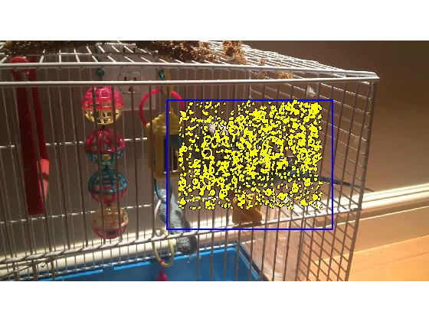

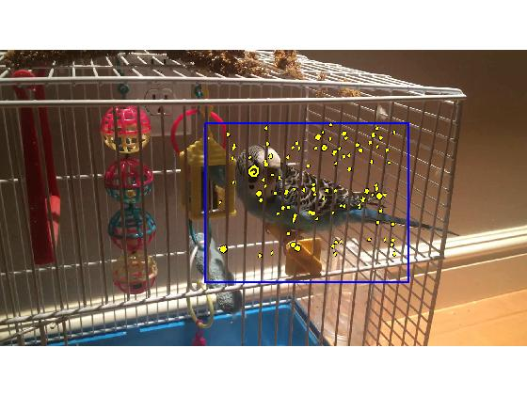

2.2 Other frames

* + Considering the bird didn’t make big movement in the clip, I just slightly enlarged the window (original window + [-50, -50, 100, 100]) when performing feature detection on the proceeding frames.

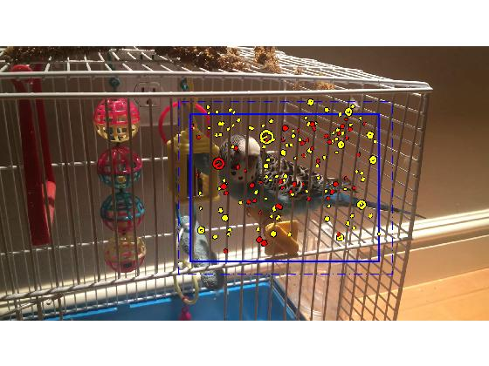

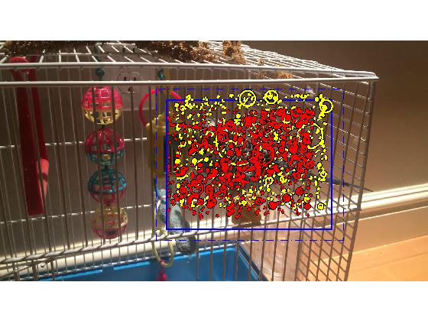

* + If a new found feature is matched with the one in existing feature bag, it is marked in red. Otherwise, it is drawn in yellow.
  + The algorithm of updating the feature bag is described as:
    - Keep the matched features
    - Remove unmatched features
    - Use the positions of matched features to determine the center of the feature window, and the size of the window stays with 640\*480
    - Only if a new detected feature is in the window, it’ll be added into the feature bag.
    - (Only applied for the second round) if the number of new features is larger than 100, then only 100 features are randomly picked.

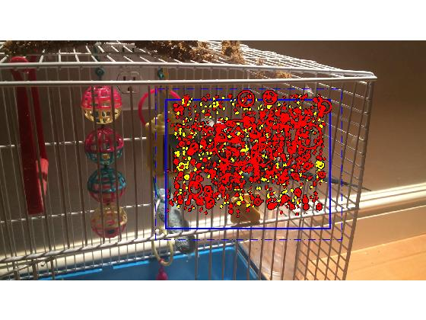

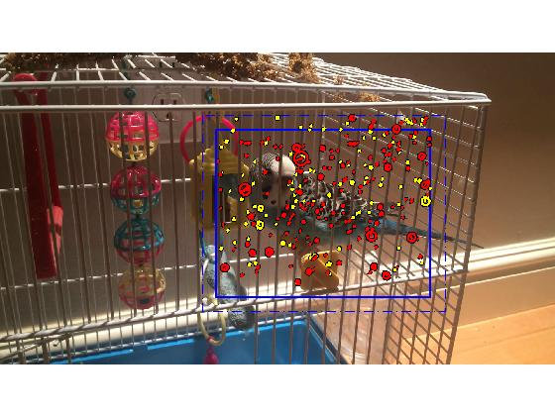

2.2 The Output

* + [Round 1: keep all features](result1.txt)

*Total 151 frames in the clip*

*1355 features found the first frame...*

*On frame 2 matched 734 feature(s), removed 621 feature(s) and inserted 672 feature(s)...*

*On frame 3 matched 1054 feature(s), removed 352 feature(s) and inserted 337 feature(s)...*

*On frame 4 matched 994 feature(s), removed 397 feature(s) and inserted 478 feature(s)...*

*On frame 5 matched 1200 feature(s), removed 272 feature(s) and inserted 298 feature(s)...*

*….*

*On frame 150 matched 1453 feature(s), removed 191 feature(s) and inserted 214 feature(s)...*

*On frame 151 matched 1426 feature(s), removed 241 feature(s) and inserted 267 feature(s)...*

* + [Round 2: randomly keep 100 features](result2.txt)

*Total 151 frames in the clip*

*100 features were randomly selected from 1355 features found the first frame...*

*On frame 2 matched 51 feature(s), removed 49 feature(s) and inserted 100 feature(s)...*

*On frame 3 matched 118 feature(s), removed 33 feature(s) and inserted 100 feature(s)...*

*On frame 4 matched 166 feature(s), removed 52 feature(s) and inserted 100 feature(s)...*

*On frame 5 matched 231 feature(s), removed 35 feature(s) and inserted 100 feature(s)...*

*…*

*On frame 150 matched 713 feature(s), removed 62 feature(s) and inserted 100 feature(s)...*

*On frame 151 matched 720 feature(s), removed 93 feature(s) and inserted 100 feature(s)...*

As can be seen, with the movement of the bird there were always new features detected and total number of feature kept increasing.

## Task II: 2 viewpoint image sets matching and relative calculations

1. 3 Image sets
   * Adirondack-perfect
   * Motorcycle-perfect
   * Recycle-perfect
2. Experiment Steps
   * Images’ feature matching (existing code)
   * Calculate the homographic model (existing code)
   * Estimate the fundamental Matrix
   * Calculate and draw to epipolar lines
   * Compute the disparity and depth by using the equation

Z = baseline \* f / (d + doffs)

1. Results

|  |  |  |  |  |
| --- | --- | --- | --- | --- |
| Set | Set Name | Depth (mm) | Fundamental Matrix | Epipolar Line Image |
| 1 | Adirondack-perfect | 2733.9 | <fm.txt> | [im\_epipolarline.jpg](result/im_epipolarline.jpg) |
| 2 | Motorcycle-perfect | 2861.5 | [fm.txt](file:///D:\Shared\work\vlfeat\fm.txt) | [im1\_epipolarline.jpg](result/im1_epipolarline.jpg) |
| 3 | Recycle-perfect | 1934.2 | [fm.txt](file:///D:\Shared\work\vlfeat\fm.txt) | [im2\_epipolarline.jpg](result/im2_epipolarline.jpg) |

I failed to query information from the pfm files with ‘cvkit’. It seems like the calib.txt is not exactly the format that the tools required. So I can’t compare my calculation with the ground truth.

## Task III: image matching and mosaic

No coding work here. Just play around the sample code and images downloaded from internet.





Original images acquired from internet

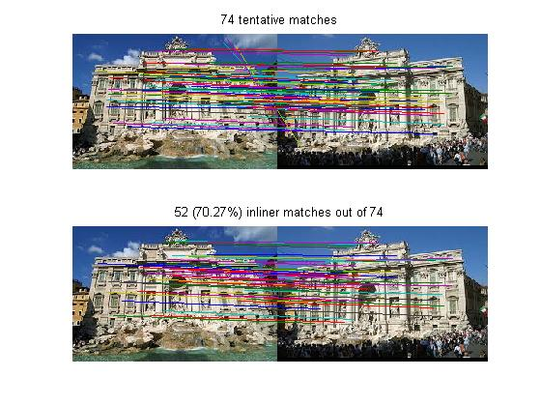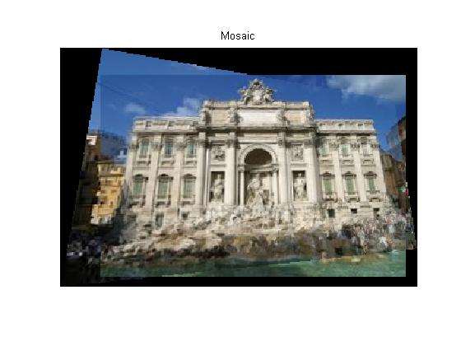

## Appendix: source code files

|  |  |  |  |
| --- | --- | --- | --- |
| Task | File Name | Description | Note |
| I | <task1.m> | Task main program |  |
| I | <DetectFeature.m> | Detect features and draw tracker box |  |
| I | <MatchFeature.m> | Match features and update feature bag |  |
| II | <sift_nomosaic.m> | 2 viewpoint images matching, fundamental matrix calculating, epipolar lines, and depth calculation | Modified based on sift\_mosaic.m |
| III | <sift_mosaic.m> | Feature matching and mosaic computing | vlfeat source code |